**PingApp**

Network Reachability App coded in Python

Created by Travis Carr

Date of creation: 05/19/2021

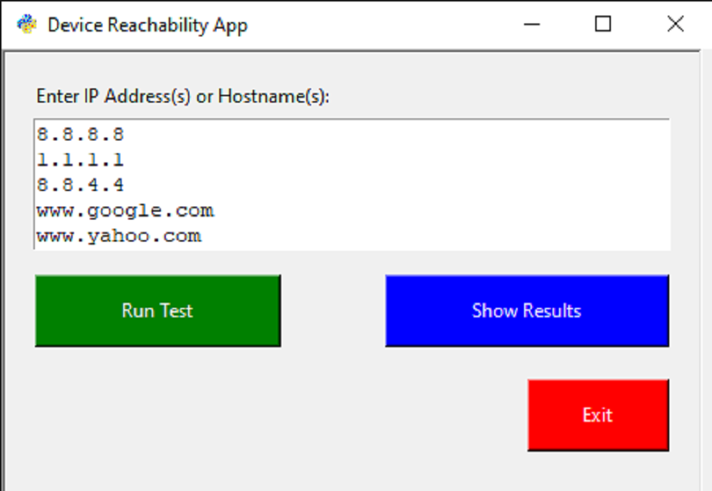

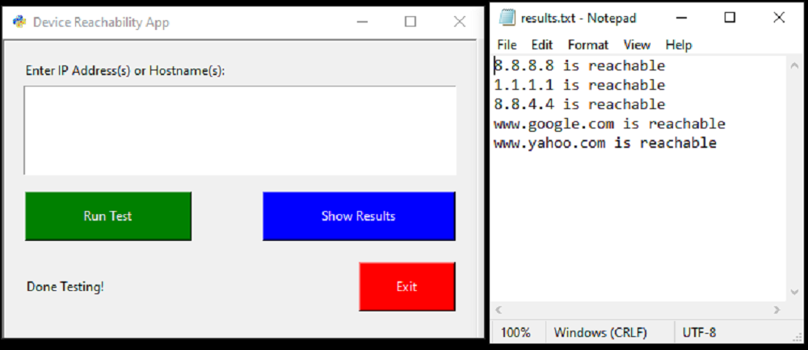

**Pre-requisites**

Make sure you have the latest version of Python installed on your system

- https://www.python.org/downloads/

Install Tkinter

- run pip install tk from any terminal

That’s it!!

**To Run Python App**

- Double click on file name, pingAppV7.py

- Enter your desired IP Address/Hostnames one line at a time

- Then click on 'Run Test', depending on the amount of hostnames or IP addresses, this process may take a few seconds

- When the test is done you will see the text "Done Testing! appear inside the app window

- Click on the 'Show Results' button to see the result of the testing

- Click the 'Exit' button to close the app when your finish.